*** 150 Points
15 March 2023 10:02
Input & output
Variable assignment
Simple calculations
Selection with algorithm/flowchart provided
Quick Notes Page 92
150 - Name Change
15 March 2023 10:03

150 pts - Name Change
SCREENSHOT YOUR COMMENTED CODE HERE
Write a program which will ask the user their name, and then respond with a suitable message.
The input will be in the format of a full name.
- e.g. "Mr Reid"
The output will be in the format of a message. - e.g. "Hello, Mr Reid"
SCREENSHOT THE OUTPUT HERE

150 - Area Calc
15 March 2023 10:03
SCREENSHOT YOUR COMMENTED CODE HERE

150 pts - Area Calc
Design and implement a program that allows the user to enter 2 numbers representing the width and length of a rectangle.
The program calculates and displays the area of the rectangle.
SCREENSHOT THE OUTPUT HERE

150 - Largest Number
15 March 2023 10:03
A programmer has written a Python program that asks the user to input two integers and then output which of the two integers is the largest.
Complete the program below by filling in the gaps using the items in the box. You will not need to use all the items. Each item should only be used once.
SCREENSHOT YOUR COMMENTED CODE HERE

print | num1 | num2 | output
else | < | > | elif
str | float | int
num1 = int(input("Enter a number: ")) num2 = ____________________ (input("Enter a second number: "))
if num1 > num2:
print(" ____________________ is bigger.")
elif num1 ____________________ num2:
print(" ____________________ is bigger.")
____________________ print("The numbers are equal.")
SCREENSHOT THE OUTPUT HERE

150 - Number Changer
15 March 2023 10:03
SCREENSHOT YOUR COMMENTED CODE HERE
Write a program which will ask the user to enter four unique numbers.
The program will then do four different mathematical equations with the numbers.
It will add them, subtract them, multiply them and divide them.
It will then output the four new numbers to the user.
SCREENSHOT THE OUTPUT HERE

150 - Jim's Bonus Scheme
26 March 2020 08:07
Jim is writing a program to calculate the wages of workers in a teddy bear factory.
Workers sometimes get a £50 bonus.
Here is the algorithm used to calculate whether a worker should get a bonus.
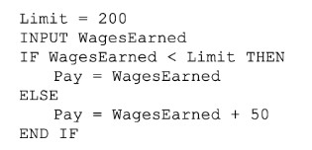
SCREENSHOT YOUR COMMENTED CODE HERE
Rewrite the algorithm as a Python program.
SCREENSHOT THE OUTPUT HERE

Solution - 150 - Area Calc
15 March 2023 10:03

150 pts - Area Calc
Design and implement a program that allows the user to enter 2 numbers representing the width and length of a rectangle.
The program calculates and displays the area of the rectangle.
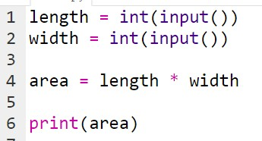

Solution 150 - Largest Number
15 March 2023 10:03
A programmer has written a Python program that asks the user to input two integers and then output which of the two integers is the largest.
Complete the program below by filling in the gaps using the items in the box. You will not need to use all the items. Each item should only be used once.

print | num1 | num2 | output
else | < | > | elif
str | float | int
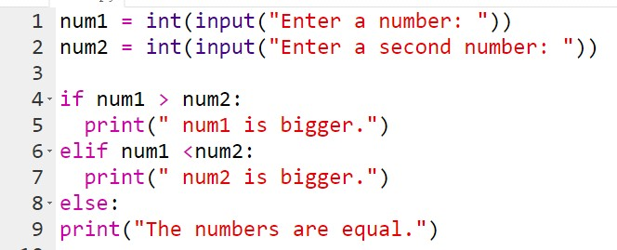
https://trinket.io/python3/9a3d991bfa
From <https://trinket.io/library/trinkets/9a3d991bfa>

Solution 150 - Number Changer
15 March 2023 10:03
Write a program which will ask the user to enter four unique numbers.
The program will then do four different mathematical equations with the numbers.
It will add them, subtract them, multiply them and divide them.
It will then output the four new numbers to the user.
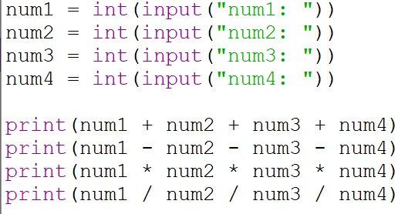

Solution - 150 - Jim's Bonus Scheme
26 March 2020 08:07
Jim is writing a program to calculate the wages of workers in a teddy bear factory.
Workers sometimes get a £50 bonus.
Here is the algorithm used to calculate whether a worker should get a bonus.

SCREENSHOT YOUR COMMENTED CODE HERE
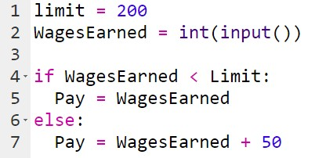
https://trinket.io/python3/b4b1242d4f
Rewrite the algorithm as a Python program.
SCREENSHOT THE OUTPUT HERE
Quick Notes Page 101
Solution 150 - Name Change
15 March 2023 10:03

150 pts - Name Change
SCREENSHOT YOUR COMMENTED CODE HERE
Write a program which will ask the user their name, and then respond with a suitable message.
The input will be in the format of a full name.
- e.g. "Mr Reid"
The output will be in the format of a message. - e.g. "Hello, Mr Reid"
SCREENSHOT THE OUTPUT HERE

*** 250 Points
15 March 2023 10:02
Selection,
Simple casting
Calculations
Quick Notes Page 103

Bigger and Bigger
10:03
SCREENSHOT YOUR COMMENTED CODE HERE
Design and implement a program that allows the user to enter 3 numbers in any order.
The program displays the largest number.
SCREENSHOT THE OUTPUT HERE

Form Chooser
10:03
Design and implement a program that allows the user to enter his/her name and form.
When a button is clicked, the program greets the user by name and tells him/her which room to go to for registration.
SCREENSHOT YOUR COMMENTED CODE HERE
SCREENSHOT THE OUTPUT HERE
Form | Room
10A | 0.12
10B | 1.23
10C | 2.34
Forms and rooms are:
Eg Inputs: Ben, 10A
Output: Hello Ben, please go to Room 0.12

Taxi Fare
10:03
Write a Python program that allows a taxi company to calculate how much a taxi fare should be.
The program should:
SCREENSHOT YOUR COMMENTED CODE HERE
- allow the user to enter the journey distance in kilometres (no validation is required)
- allow the user to enter the number of passengers (no validation is required)
- calculate the taxi fare by
○ charging £2 for every passenger regardless of the distance
○ charging a further £1.50 for every kilometre regardless of how many passengers there are
- output the final taxi fare.
You should use meaningful variable name(s), correct syntax and indentation in your answer.
SCREENSHOT THE OUTPUT HERE

Password Check
10:03
Write a Python program that inputs a password and checks if it is correct.
Your program should work as follows:
SCREENSHOT YOUR COMMENTED CODE HERE
- input a password and store it in a suitable variable
- if the password entered is equal to secret display the message Welcome
- if the password entered is not equal to secret display the message Not welcome.
You should use meaningful variable name(s), correct syntax and indentation in your answer.
SCREENSHOT THE OUTPUT HERE

Secret Agent
10:03
Write a program that will tell secret agents where to pick up intel packages.
SCREENSHOT YOUR COMMENTED CODE HERE
The program MUST only tell the secret agent and not anybody else, therefore they will need a secret code to get the information. The code should be a series of 6 letters.
You will need to start by storing the secret code: HTSSAW
The user will then need to enter the code.
If the codes match, you will need to output a suitable message. E.g.
- "The package will be at 231 Marsden Street" If not, it will display a fake message. - "Nothing to see here..."
SCREENSHOT THE OUTPUT HERE

New Email
10:03
Write a Python program to check if an email address has been entered correctly by a user.
Your program must:
- get the user to input an email address
SCREENSHOT YOUR COMMENTED CODE HERE
- get the user to input the email address a second time
- output the message Match and output the email address if the email addresses entered are the same
- output the message Do not match if the email addresses entered are not the same.
You should use indentation as appropriate, meaningful variable name(s) and Python syntax in your answer.
SCREENSHOT THE OUTPUT HERE

Bonus Payment
10:03
Write a Python program that calculates the value of a bonus payment for an employee based on how many items they have sold and the number of years they have been employed. The program should:
SCREENSHOT YOUR COMMENTED CODE HERE
- get the user to input the number of items sold • get the user to input the number of years employed
- output the value of the bonus payment: ○ if the years of employment is less than or equal to 2 and the number of items sold is greater than 100, then the bonus will be the number of items sold multiplied by 2 ○ if the years of employment is greater than 2, then the bonus will be the number of items sold multiplied by 10 ○ otherwise, the bonus is 0
You should use indentation as appropriate, meaningful variable name(s) and Python syntax in your answer.
SCREENSHOT THE OUTPUT HERE

BMI Checker
10:03
To calculate a users BMI : Weight in KG / Height in Meters squared
*Underweight BMI = Less than 18.5
*Normal Weight BMI = Between 18.6 & 24.9
*Overweight BMI = Over 25
SCREENSHOT YOUR COMMENTED CODE HERE
The user should be asked to input their weight in KG's and Height in Meters. E.g.
- "What is your weight in KG's?"
- "50"
- "What is your height in Meters?"
- "1.75"
Your program should then work out their BMI and tell them what it is, followed by whether they are underweight, normal weight, or overweight.
- "Your BMI is 16.3. You are underweight."
SCREENSHOT THE OUTPUT HERE

Secret Agent
10:03
Write a program that will tell secret agents where to pick up intel packages.
SCREENSHOT YOUR COMMENTED CODE HERE
The program MUST only tell the secret agent and not anybody else, therefore they will need a secret code to get the information. The code should be a series of 6 letters.
You will need to start by storing the secret code: HTSSAW The user will then need to enter the code.
If the codes match, you will need to output a suitable message. E.g.
- "The package will be at 231 Marsden Street" If not, it will display a fake message. - "Nothing to see here..."
SCREENSHOT THE OUTPUT HERE

Magic 8 Ball
10:03
Write a program that will give the user a random answer to a yes or no question.
The user will be asked to enter their question. The program will then give them an answer from the following options:
- "Definitely"
- "Most Probably"
- "Its still unclear"
- "Not Likely"
SCREENSHOT YOUR COMMENTED CODE HERE
SCREENSHOT THE OUTPUT HERE
- "No Chance"
For this program you will need to import the random module.
You will then let the user enter a yes or no question. E.g.
- "Will I win the lottery this week?"
Your program will then randomise a response from the above. E.g. - "No Chance"
Extra Challenge - 200 points
Use a list to store all of the output statements.
The program should randomly choose one statement from the list.

250 - km to Miles
26 March 2020 08:07
Write a program that can convert kilometres into miles, and vice versa.
* 1KM = 0.62 Miles * 1Mile = 1.6 KM
The program will ask the user to pick if they are entering Miles or Kilometres. E.g. - "Are you entering miles or km?"
- "miles"
It will then ask for the amount of miles or km. The user will enter this as a whole number. - 7
The program will then convert their input and output the result.
- 11.2
SCREENSHOT YOUR COMMENTED CODE HERE
If the users input is not miles or km, output an error message.
SCREENSHOT THE OUTPUT HERE

Write a Python program that calculates the value of a bonus
payment for an employee based on how many items they
have sold and the number of years they have been
employed.
The program should:
•

get the user to input the number of items sold
•

get the user to input the number of years employed
•

output the value of the bonus payment:
○

if the years of employment is less than or equal to 2
and
the number of items sold is greater than 100, then the bonus
will be the number of items sold multiplied by 2
○

if the years of employment is greater than 2, then the
bonus will be the number of items sold multiplied by 10
○

otherwise, the bonus is 0
You
should
use indentation as appropriate, meaningful
variable name(s) and Python syntax in your answer.
SCREENSHOT YOUR COMMENTED CODE HERE
SCREENSHOT THE OUTPUT HERE

250
-
Bonus Payment
2023
March
15
10:03

250 - BMI Checker
26 March 2020 08:07
Write a program that will check a users BMI and output this to them, with a message about whether they are healthy or not.
*To calculate a users BMI : Weight in KG / Height in Meters squared
*Underweight BMI = Less than 18.5
*Normal Weight BMI = Between 18.6 & 24.9 *Overweight BMI = Over 25
The user should be asked to input their weight in KG's and Height in Meters. E.g. - "What is your weight in KG's?"
- "50"
- "What is your height in Meters?"
- "1.75"
Your program should then work out their BMI and tell them what it is followed by whether they are underweight, normal weight, or overweight.
- "Your BMI is 16.3. You are underweight."
Extra challenge - 50 pts
The BMI should be rounded to 2 decimal places.
SCREENSHOT YOUR COMMENTED CODE HERE
SCREENSHOT THE OUTPUT HERE

250 - Random Number Generator
26 March 2020 08:07
Write a program that will generate a random whole number based on a users preference.
For example, if a user wanted a random number between 1 and 50, the program would output a random number in this range.
Allow the user to input two different numbers: Min and max of range. You will want to store these numbers as two different values. E.g. - "1"
- "20"
You will then generate a random number between these values and output it to the user. E.g. - "13"
SCREENSHOT YOUR COMMENTED CODE HERE
SCREENSHOT THE OUTPUT HERE

Bigger and Bigger
SCREENSHOT YOUR COMMENTED CODE HERE
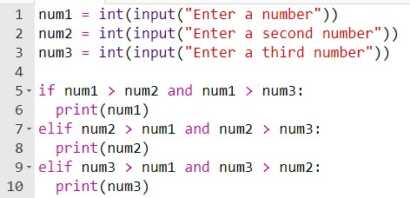
https://trinket.io/python3/faf329be13
From <https://trinket.io/library/trinkets/faf329be13>
SCREENSHOT THE OUTPUT HERE
Design and implement a program that allows the user to enter 3 numbers in any order.
The program displays the largest number.

Form Chooser
Write a program that allows the user to enter his/her name and form.
SCREENSHOT YOUR COMMENTED CODE HERE
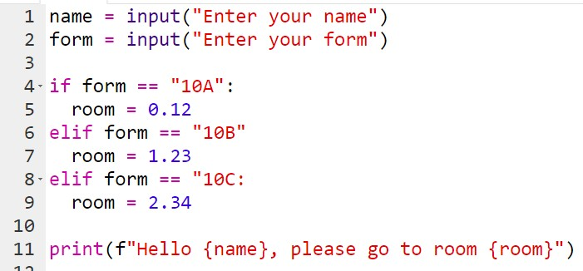
https://trinket.io/python3/e629f8b26c
From <https://trinket.io/library/trinkets/e629f8b26c>
SCREENSHOT THE OUTPUT HERE
When a button is clicked, the program greets the user by name and tells him/her which room to go to for registration.
Eg Inputs: Ben, 9T
Output: Hello Ben, please go to Room 16

Taxi Fare
Write a Python program that allows a taxi company to calculate how much a taxi fare should be.
The program should:
- allow the user to enter the journey distance in kilometres (no validation is required)
SCREENSHOT YOUR COMMENTED CODE HERE
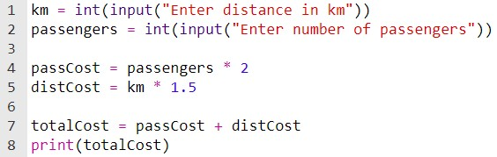
https://trinket.io/python3/449eb4936b
From <https://trinket.io/library/trinkets/449eb4936b>
SCREENSHOT THE OUTPUT HERE
- allow the user to enter the number of passengers (no validation is required)
- calculate the taxi fare by
◦ | charging £2 for every passenger regardless of the distance
◦ | charging a further £1.50 for every kilometre regardless of how many passengers there are
- output the final taxi fare.
You should use meaningful variable name(s), correct syntax and indentation in your answer.

Password Check
Write a Python program that inputs a password and checks if it is correct.
Your program should work as follows:
SCREENSHOT YOUR COMMENTED CODE HERE
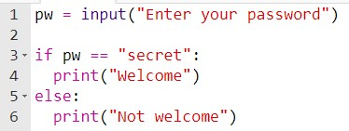
SCREENSHOT THE OUTPUT HERE
- input a password and store it in a suitable variable
- if the password entered is equal to secret display the message Welcome
- if the password entered is not equal to secret display the message Not welcome.
You should use meaningful variable name(s), correct syntax and indentation in your answer.

Secret Agent
Write a program that will tell secret agents where to pick up intel packages.
SCREENSHOT YOUR COMMENTED CODE HERE
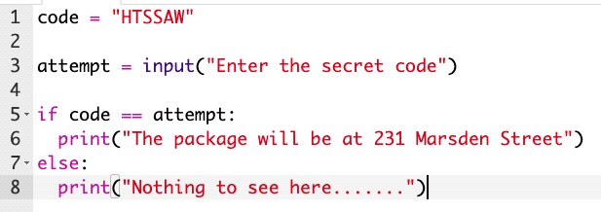
https://trinket.io/python3/f76972ed85
SCREENSHOT THE OUTPUT HERE
The program MUST only tell the secret agent and not anybody else, therefore they will need a secret code to get the information. The code should be a series of 6 letters.
You will need to start by storing the secret code: HTSSAW The user will then need to enter the code.
If the codes match, you will need to output a suitable message. E.g.
- "The package will be at 231 Marsden Street" If not, it will display a fake message. - "Nothing to see here..."

New Email
Write a Python program to check if an email address has been entered correctly by a user.
Your program must:
- get the user to input an email address
SCREENSHOT YOUR COMMENTED CODE HERE
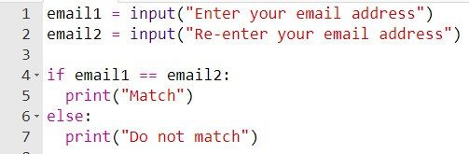
https://trinket.io/python3/5e0a4f2ae2
From <https://trinket.io/library/trinkets/5e0a4f2ae2>
SCREENSHOT THE OUTPUT HERE
- get the user to input the email address a second time
- output the message Match and output the email address if the email addresses entered are the same
- output the message Do not match if the email addresses entered are not the same.
You should use indentation as appropriate, meaningful variable name(s) and Python syntax in your answer.

Bonus Payment
Write a Python program that calculates the value of a bonus payment for an employee based on how many items they have sold and the number of years they have been employed.
The program should:
SCREENSHOT YOUR COMMENTED CODE HERE
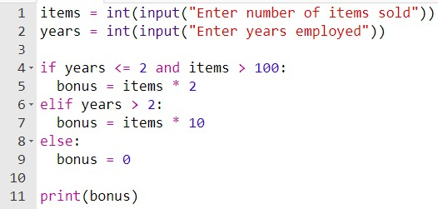
https://trinket.io/python3/c5d096a29a
From <https://trinket.io/library/trinkets/c5d096a29a>
SCREENSHOT THE OUTPUT HERE
- get the user to input the number of items sold • get the user to input the number of years employed
- output the value of the bonus payment: ○ if the years of employment is less than or equal to 2 and the number of items sold is greater than 100, then the bonus will be the number of items sold multiplied by 2 ○ if the years of employment is greater than 2, then the bonus will be the number of items sold multiplied by 10 ○ otherwise, the bonus is 0
You should use indentation as appropriate, meaningful variable name(s) and Python syntax in your answer.

Magic 8 Ball
Write a program that will give the user a random answer to a yes or no question.
The user will be asked to enter their question. The program will then give them an answer from the following options:
- "Definitely"
SCREENSHOT YOUR COMMENTED CODE HERE
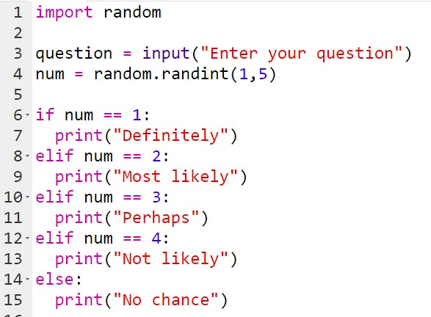
https://trinket.io/python3/59190d71ee
From <https://trinket.io/library/trinkets/59190d71ee>
SCREENSHOT THE OUTPUT HERE
- "Most Probably"
- "Its still unclear"
- "Not Likely"
- "No Chance"
For this program you will need to import the random module.
You will then let the user enter a yes or no question. E.g.
- "Will I win the lottery this week?"
Your program will then randomise a response from the above. E.g. - "No Chance"

Solution - 250 - km to Miles
26 March 2020 08:07
Write a program that can convert kilometres into miles, and vice versa.
* 1KM = 0.62 Miles * 1Mile = 1.6 KM
The program will ask the user to pick if they are entering Miles or Kilometres. E.g. - "Are you entering miles or km?"
- "miles"
It will then ask for the amount of miles or km. The user will enter this as a whole number. - 7
The program will then convert their input and output the result.
- 11.2
SCREENSHOT YOUR COMMENTED CODE HERE
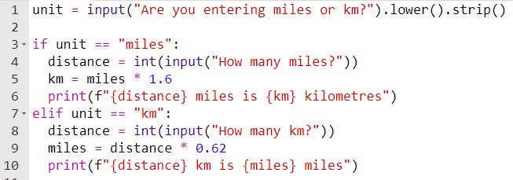
https://trinket.io/python3/3277abbae0
From <https://trinket.io/library/trinkets/3277abbae0>
If the users input is not miles or km, output an error message.
SCREENSHOT THE OUTPUT HERE
Quick Notes Page 126

Solution - 250 - BMI Checker
15 March 2023 10:03
To calculate a users BMI : Weight in KG / Height in Meters squared
*Underweight BMI = Less than 18.5
*Normal Weight BMI = Between 18.6 & 24.9
*Overweight BMI = Over 25
The user should be asked to input their weight in KG's and Height in Meters. E.g.
- "What is your weight in KG's?"
- "50"
- "What is your height in Meters?"
- "1.75"
Your program should then work out their BMI and tell them what it is, followed by whether they are underweight, normal weight, or overweight.
SCREENSHOT YOUR COMMENTED CODE HERE
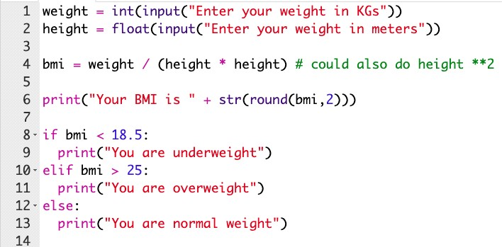
https://trinket.io/python3/9191d229cb
- "Your BMI is 16.3. You are underweight."
SCREENSHOT THE OUTPUT HERE
Quick Notes Page 127

Solution - 250 - Random Number Generator
26 March 2020 08:07
Write a program that will generate a random whole number based on a users preference.
For example, if a user wanted a random number between 1 and 50, the program would output a random number in this range.
Allow the user to input two different numbers: Min and max of range. You will want to store these numbers as two different values. E.g. - "1"
- "20"
You will then generate a random number between these values and output it to the user. E.g. - "13"
SCREENSHOT YOUR COMMENTED CODE HERE
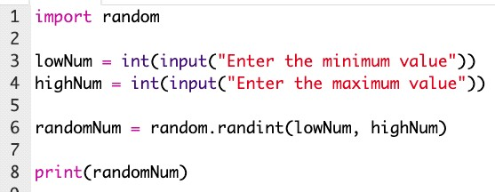
https://trinket.io/python3/53970fc049?showInstructions=true
SCREENSHOT THE OUTPUT HERE

*** 500 Points
15 March 2023 13:22
Loops
Nested Selection
String Manipulation
More complex calculations (DIV, MOD etc)
Quick Notes Page 129

Ice Cream!
10:03
Write a program that helps an ice cream seller in a hot country calculate how many ice creams they are likely to sell on a particular day.
Your algorithm should:
- get the user to enter whether it is the weekend or a weekday
SCREENSHOT YOUR COMMENTED CODE HERE
SCREENSHOT THE OUTPUT HERE
- get the user to enter the temperature forecast in degrees Celsius (they should enter a number between 20 and 45 inclusive; if the number falls outside of this range then they should be made to reenter another number until they enter a valid temperature)
- calculate the number of ice creams that are likely to be sold using the following information:
○ 100 ice creams are likely to be sold if the temperature is between 20 and 30 degrees inclusive,
○ 150 ice creams are likely to be sold if the temperature is between 31 and 38 degrees inclusive,
○ and 120 ice creams are likely to be sold if the temperature is higher than 38 degrees
- double the estimate if it is a weekend
- output the estimated number of ice creams that are likely to be sold.

Cake Maker
10:03
A cake recipe uses 100 grams of flour and 50 grams of sugar for every egg used box in the recipe.
The number of eggs is entered by the user.
SCREENSHOT YOUR COMMENTED CODE HERE
SCREENSHOT THE OUTPUT HERE
The developer wants to use validation to ensure that the user can only enter a positive number of eggs, ie one egg or more.
The maximum number of eggs that can be used in the recipe is eight.
Write a program so that the number of eggs is validated to ensure the user is made to re-enter the number of eggs used until a valid number is entered.
You should assume that the user will always enter an integer.

Five A Day
10:03
SCREENSHOT YOUR COMMENTED CODE HERE
Design and implement a program that allows the user to enter a positive number.
The program displays all of the numbers divisible by 5 up to the number entered.
Eg the user enters 30, the program displays 5, 10, 15,
20, 25, 30
SCREENSHOT THE OUTPUT HERE

Squares and Cubes
10:03
SCREENSHOT YOUR COMMENTED CODE HERE
The squared number sequence starts: 1, 4, 9, 16, 25. The cubed number sequence starts: 1, 8, 27, 64.
Design and write a program to display N numbers in the squared or cubed sequence according to user choice.
SCREENSHOT THE OUTPUT HERE

Lower Case
10:03
Write a Python program that inputs a character and checks to see if it is lowercase or not.
Your program should work as follows:
SCREENSHOT YOUR COMMENTED CODE HERE
- gets the user to enter a character and store it in a suitable variable
- determines if the entered character is a lowercase character
- outputs LOWER if the user has entered a lowercase character
- outputs NOT LOWER if the user has entered any other character.
You should use meaningful variable name(s), correct syntax and indentation in your answer.
SCREENSHOT THE OUTPUT HERE

Go Kart
10:03
Write a Python program that calculates an estimate of the braking distance in metres for a new model of gokart that is travelling between 10 and 50 kilometres per hour (kph).
Your program should:
SCREENSHOT YOUR COMMENTED CODE HERE
SCREENSHOT THE OUTPUT HERE
- keep asking the user to enter a speed for the go-kart until they enter a speed that is between 10 and 50 (inclusive)
- calculate the braking distance in metres by dividing the speed by 5
- ask the user if the ground is wet (expect the user to enter yes if it is)
- if the ground is wet, multiply the braking distance by 1.5
- output the final calculated braking distance.
You should use meaningful variable name(s), correct syntax and indentation in your answer.

500 - Pick A Card
15 March 2023 10:03
A program is being developed in Python to simulate a card game.
Throughout the game each player always has 100 cards. Each card displays a number.
Players take it in turns to swap one of their cards with another random card from a set of cards until a player has a run of five numbers in sequence within their 100 cards.
The figure below shows part of the program that will get a player to enter the position of a card to swap.
position = int(input("Enter card position: "))
Extend the program in the figure above. Your answer must be written in Python.
The program should keep getting the user to enter the card position until they enter a card position that is between 1 and 100 inclusive.
You should use indentation as appropriate, meaningful variable name(s) and Python syntax in your answer.
SCREENSHOT YOUR COMMENTED CODE HERE
SCREENSHOT THE OUTPUT HERE
Quick Notes Page 136
500 - Darts
15 March 2023 10:03
Create a program that can tell a user how many points off 180
they are after throwing 3 darts.
The program must check the score to make sure it is valid (A single dart cannot score greater than 60).
The user will enter three integers representing each dart.
**The maximum number a dart can score is 60.**
- "20"
- "40"
- "5"
You will then output the remaining number of points they would have needed to get the maximum score of 180.
- "115"
SCREENSHOT YOUR COMMENTED CODE HERE
SCREENSHOT THE OUTPUT HERE
Quick Notes Page 137

500 - Averages
Sunday, 16 April 2023 15:36
Write a program that lets a user work out the average of a series of numbers.
The user should be able to specify how many numbers they wish to check before inputting the numbers.
You should ask for two different kinds inputs: The amount of
numbers and the numbers themselves. E.g
- 4
- 17
- 21
- 14
- 11
The program will then output the average of the input numbers. E.g.
- 15.75
SCREENSHOT YOUR COMMENTED CODE HERE
SCREENSHOT THE OUTPUT HERE
Quick Notes Page 138

500 - Times Tables
26 March 2020 08:07
Write a program that will list the times table from 1 to 12 for any number the user enters.
The program should ask the user for a single number input. E.g.
- 2
It will then print out the times tables in a friendly format. E.g. 1 x 2 = 2 2 x 2 = 4
3 x 2 = 6 4 x 2 = 8
- x 2 = 10
- x 2 = 12
- x 2 = 14
- x 2 = 16
- x 2 = 18
- x 2 = 20
- x 2 = 22
- x 2 = 24
SCREENSHOT YOUR COMMENTED CODE HERE
The program must print out all 12 for this challenge to be complete.
SCREENSHOT THE OUTPUT HERE
Quick Notes Page 139
Solution - 500 - Ice Cream!
15 March 2023 10:03
Write a program that helps an ice cream seller in a hot country calculate how many ice creams they are likely to sell on a particular day.
Your algorithm should:
- get the user to enter whether it is the weekend or a weekday
- get the user to enter the temperature forecast in degrees Celsius (they should enter a number between 20 and 45 inclusive; if the number falls outside of this range then they should be made to reenter another number until they enter a valid temperature)
- calculate the number of ice creams that are likely to be sold using the following information:
○ 100 ice creams are likely to be sold if the temperature is between 20 and 30 degrees inclusive,
○ 150 ice creams are likely to be sold if the temperature is between 31 and 38 degrees inclusive,
○ and 120 ice creams are likely to be sold if the temperature is higher than 38 degrees
- double the estimate if it is a weekend
- output the estimated number of ice creams that are likely to be sold.
SCREENSHOT YOUR COMMENTED CODE HERE
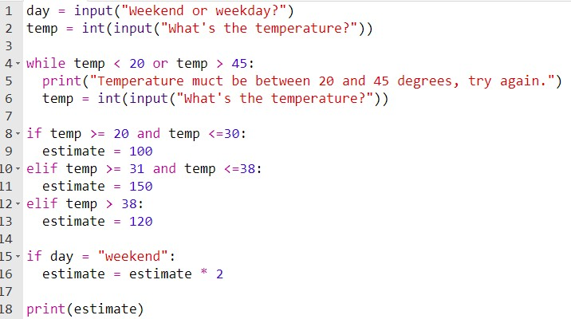
https://trinket.io/python3/1540ddbf01
From <https://trinket.io/library/trinkets/1540ddbf01>
Quick Notes Page 140

SCREENSHOT THE OUTPUT HERE
Quick Notes Page 141

Cake Maker
A cake recipe uses 100 grams of flour and 50 grams of sugar for every egg used box in the recipe.
The number of eggs is entered by the user.
SCREENSHOT YOUR COMMENTED CODE HERE
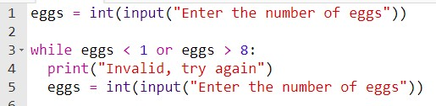
https://trinket.io/python3/b856e090a0
From <https://trinket.io/library/trinkets/b856e090a0>
SCREENSHOT THE OUTPUT HERE
The developer wants to use validation to ensure that the user can only enter a positive number of eggs, ie one egg or more.
The maximum number of eggs that can be used in the recipe is eight.
Write a program so that the number of eggs is validated to ensure the user is made to re-enter the number of eggs used until a valid number is entered.
You should assume that the user will always enter an integer.

Five A Day
SCREENSHOT YOUR COMMENTED CODE HERE
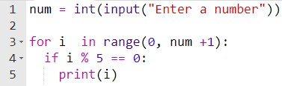
https://trinket.io/python3/b203c08ff9
From <https://trinket.io/library/trinkets/b203c08ff9>
SCREENSHOT THE OUTPUT HERE
Design and implement a program that allows the user to enter a positive number.
The program displays all of the numbers divisible by 5 up to the number entered.
Eg the user enters 30, the program displays 5, 10, 15,
20, 25, 30

Squares and Cubes
SCREENSHOT YOUR COMMENTED CODE HERE
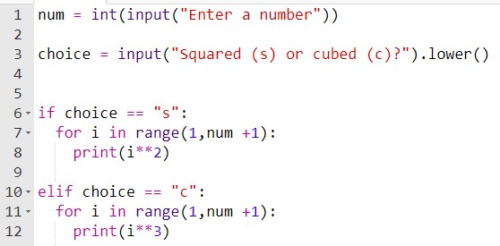
https://trinket.io/python3/b5cd086bed
From <https://trinket.io/library/trinkets/b5cd086bed>
SCREENSHOT THE OUTPUT HERE
The squared number sequence starts: 1, 4, 9, 16, 25. The cubed number sequence starts: 1, 8, 27, 64.
Design and write a program to display N numbers in the squared or cubed sequence according to user choice.

Lower Case
Write a Python program that inputs a character and checks to see if it is lowercase or not.
Your program should work as follows:
SCREENSHOT YOUR COMMENTED CODE HERE
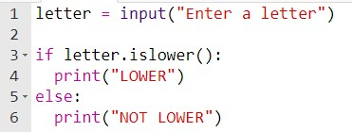
OR
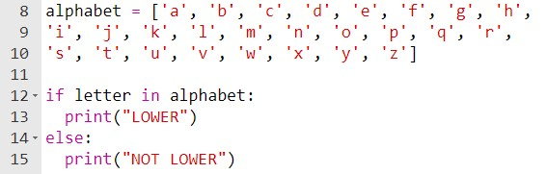
https://trinket.io/python3/8d1714992f
From <https://trinket.io/library/trinkets/8d1714992f>
SCREENSHOT THE OUTPUT HERE
- gets the user to enter a character and store it in a suitable variable
- determines if the entered character is a lowercase character
- outputs LOWER if the user has entered a lowercase character
- outputs NOT LOWER if the user has entered any other character.
You should use meaningful variable name(s), correct syntax and indentation in your answer.

Solution - 500 - Go Kart
15 March 2023 10:03
Write a Python program that calculates an estimate of the braking distance in metres for a new model of gokart that is travelling between 10 and 50 kilometres per hour (kph).
Your program should:
- keep asking the user to enter a speed for the go-kart until they enter a speed that is between 10 and 50 (inclusive)
- calculate the braking distance in metres by dividing the speed by 5
- ask the user if the ground is wet (expect the user to enter yes if it is)
- if the ground is wet, multiply the braking distance by 1.5
- output the final calculated braking distance.
You should use meaningful variable name(s), correct syntax and indentation in your answer.
SCREENSHOT YOUR COMMENTED CODE HERE
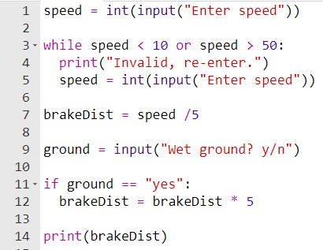
https://trinket.io/python3/f50d8a2461
From <https://trinket.io/library/trinkets/f50d8a2461>
Quick Notes Page 146
SCREENSHOT THE OUTPUT HERE
Quick Notes Page 147
Solution - 500 - Pick A Card
15 March 2023 10:03
A program is being developed in Python to simulate a card game.
Throughout the game each player always has 100 cards. Each card displays a number.
Players take it in turns to swap one of their cards with another random card from a set of cards until a player has a run of five numbers in sequence within their 100 cards.
The figure below shows part of the program that will get a player to enter the position of a card to swap.
position = int(input("Enter card position: "))
Extend the program in the figure above. Your answer must be written in Python.
The program should keep getting the user to enter the card position until they enter a card position that is between 1 and 100 inclusive.
You should use indentation as appropriate, meaningful variable name(s) and Python syntax in your answer.
SCREENSHOT YOUR COMMENTED CODE HERE
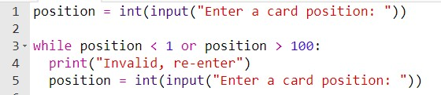
https://trinket.io/python3/3c1f308429
From <https://trinket.io/library/trinkets/3c1f308429>
SCREENSHOT THE OUTPUT HERE
Quick Notes Page 148 Quick Notes Page 149
Solution - 500 - Darts
15 March 2023 10:03
Create a program that can tell a user how many points off 180
they are after throwing 3 darts.
The program must check the score to make sure it is valid (A single dart cannot score greater than 60).
The user will enter three integers representing each dart.
**The maximum number a dart can score is 60.**
- "20"
- "40"
- "5"
You will then output the remaining number of points they would have needed to get the maximum score of 180.
- "115"
SCREENSHOT YOUR COMMENTED CODE HERE
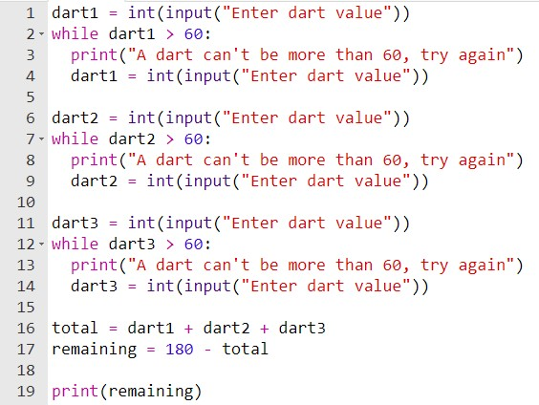
https://trinket.io/python3/3fe4fb168f
From <https://trinket.io/library/trinkets/3fe4fb168f>
Quick Notes Page 150
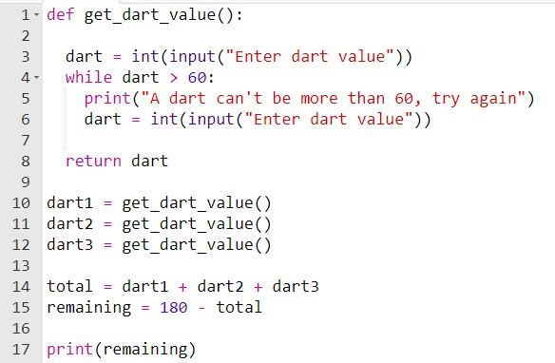
https://trinket.io/python3/5366e0b51
5
From <
https://trinket.io/library/trinkets/5366e0b51
5
>

SCREENSHOT THE OUTPUT HERE
Quick Notes Page 151

Solution - 500 - Averages
26 March 2020 08:17
SOLUTION
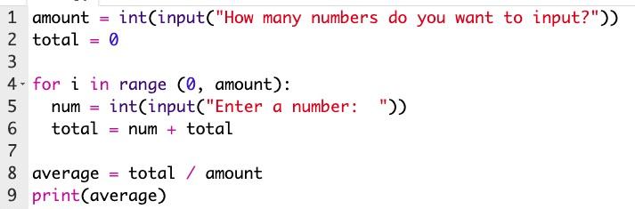
https://trinket.io/python3/5810c563db
Solution - Averages
Quick Notes Page 152

Solution - 500 - Times Tables
SOLUTION
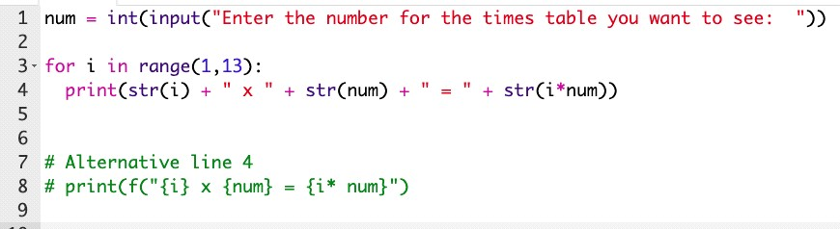
https://trinket.io/python3/fb68b9b457
26 March 2020 08:17
Quick Notes Page 153

*** 600 Pts
17 March 2023 11:25
1 D arrays
Subroutines
Boolean Flags
Complex conditional iteration
Quick Notes Page 154

Bingo!
10:03
A program is being written to simulate a computer science revision game in the style of bingo.
At the beginning of the game a bingo ticket is generated with nine different key terms from computer science in a 3 x 3 grid. An example bingo ticket is provided in Figure 1.
Figure 1

CPU | ALU | Pixel
NOT gate | Binary | LAN
Register | Cache | Protocol
The player will then be prompted to answer a series of questions. If an answer matches a key term on the player’s bingo ticket, then the key term will be marked off automatically.
Figure 2 shows an incomplete Python program to create a bingo ticket for a player
.
The programmer has used a two-dimensional array called ticket to represent a bingo ticket.
The program uses a subroutine called generateKeyTerm. When called, the subroutine will return a random key term, eg "CPU", "ALU", "NOT gate" etc.
Click here for the starter code.
Complete the Python program in Figure 2 by filling in the five gaps. Line numbers are included but are not part of the program.
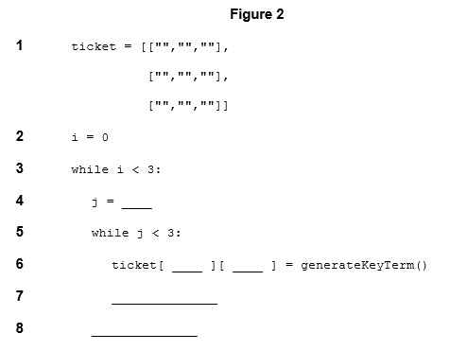
SCREENSHOT YOUR COMMENTED CODE HERE

Quick Notes Page 156
OCR Tech
10:03
OCR Tech is an online shop that sells electronics such as TVs and game consoles.
Customers can use a discount code to reduce the price of their purchase.
Valid discount codes and their value (in pounds) are stored in a global two-dimensional (2D) array with the identifier discount.
The following table shows part of this 2D array.
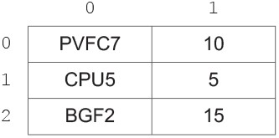
For example, discount[2,0]holds discount code BGF2 anddiscount[2,1]holds the discount of 15 pounds.
A function searches through the 2D array and applies the discount to the price. The price and discount code are passed in as parameters. The algorithm design is not complete.
Complete the design for the algorithm, you will need to rewrite the pseudocode as Python code.
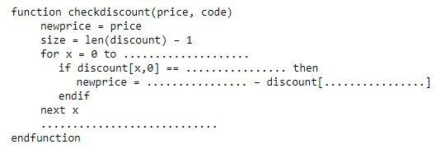
SCREENSHOT YOUR COMMENTED CODE HERE
Quick Notes Page 158
OCR FC - Goals Array
10:03
Elliott plays football for OCR FC. He wants to create a program to store the results of each football match they play and the names of the goal scorers. Elliott wants individual players from the team to be able to submit this information.
The number of goals scored in each football match is held in an array called goals. An example of this array is shown.
goals = [0, 1, 3, 0, 4, 5, 2, 0, 2, 1]
Elliott wants to count how many matches end with 0 goals.
Convert the following pseudocode for an algorithm into Python.
The program should count up how many matches with 0 goals are stored in the array and then print out this value.
Click here for the starter code.
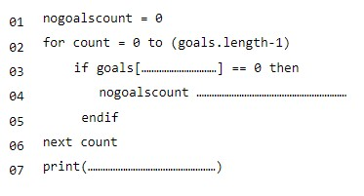
SCREENSHOT YOUR COMMENTED CODE HERE

Game Time - Day Of The Week
10:03
Heath is researching how long, to the nearest minute, each student in his class spends playing computer games in one week (Monday to Friday). He is storing the data in a 2D array.
Fig. 2 shows part of the array, with 4 students.
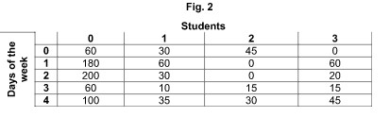
For example, student 1, on Monday (day 0), played 30 minutes of computer games.
Heath has the day of the week stored as a number e.g. 0 = Monday, 1 = Tuesday.
Write a sub-program that takes the number as a parameter and returns the day of the week as a string.
SCREENSHOT YOUR COMMENTED CODE HERE

600 - Logging In
26 March 2020 08:07
Write a program which asks a user for a unique ID. It should then check the ID against a list of ID's stored.
If the ID matches one in the list, the user will be authorised and a relevant message will display.
If not, the user will be asked to enter their ID again. They will get 3 goes before they are locked out.
You will need to create a list of ten unique ID's for this challenge.
Each ID will compromise of two letters and four numbers in the following format: - SD5545
The user will then have to enter their own ID. If the ID they enter matches one in the list, they will be greeted. E.g.
- "Hello user SD5545. You have been authorised."
If it doesn't match, they will get another two goes at entering an ID before a suitable message is displayed and they are locked out.
- "ID wrong. You have been locked out."
Each time they try and get it wrong, they should be told how many attempts they have left.
SCREENSHOT YOUR COMMENTED CODE HERE
SCREENSHOT THE OUTPUT HERE
Quick Notes Page 162

Email Validator
10:03
Write a program which can validate a users email. Once the user enters their email, it should check that there are no spaces and that the email contains an "@" symbol.
The user should be able to input their email address. E.g. - "student1@laurustrust.org.uk"
The program will then check the email to ensure it includes both an "@" symbol AND no spaces.
If it does, it will output a suitable message. E.g.
- "Your email is acceptable"
If not, it will print a different message telling them what they are missing.
- Unfortunately your password does not contain an @"
SCREENSHOT YOUR COMMENTED CODE HERE
SCREENSHOT THE OUTPUT HERE
Quick Notes Page 163
Pin Checker
08:17

Pin Checker
Write a program that can check how strong a user's PIN number is.
The user will need to input their PIN number and the program will output whether it is strong or not, and if not give the reason why.
SCREENSHOT YOUR COMMENTED CODE HERE
Pin numbers MUST be 4 digits long.
Allow the user to input their pin as an integer. E.g.
- 4335
The program will then check if the pin number is strong by making sure:
* The pin is not four consecutive numbers. E.g, '1234', or '5678' * The pin is not four identical numbers. E.g. '0000' or '8888'
If the pin is not strong, a message will appear telling them why.
Otherwise the user will be told they have a strong pin number.
SCREENSHOT THE OUTPUT HERE

6th Form Admissions
08:17
SCREENSHOT YOUR COMMENTED CODE HERE
Write a program that:
- Ask the user to input how many GCSE’s they have.
- They should then be allowed to enter a result for each GCSE grade.
- The computer should work out how many points they have got (9=9, 8=8, 7=7 etc).
● | If their score is 40 or over it should output ‘You can go to the sixth form’
● | If they their score between 35 and 39 it should output ‘A discussion is needed’
● | Otherwise it should say ‘Sorry not enough points.’
SCREENSHOT THE OUTPUT HERE

Free Electricity!
08:17
Roger has switched to a new electric supplier.
SCREENSHOT YOUR COMMENTED CODE HERE
He will receive free electric one day a week. He will not pay for the day that he uses the least amount of electricity.
Write a program that will:
- Allow the user to input each day of the week and then unit of units of electric used.
- Compare them until all comparisons are completed.
- Output the day that will be free of charge.
SCREENSHOT THE OUTPUT HERE

How Many Cars?
08:17
Roger has switched to a new electric supplier.
He will receive free electric one day a week. He will not pay for the day that he uses the least amount of electricity.
SCREENSHOT YOUR COMMENTED CODE HERE
Write a program that:
- Asks the user to input many cars are available for a trip.
- Asks the user to input how many people are going on the trip.
- If there are enough seats it should output ‘We have enough seats’
- If there are not enough seats it calculate how many extra cars are needed and then output ‘Another x cars are needed’ with x being the number of cars.
NOTE: Assume you can fit FIVE people in each car.
SCREENSHOT THE OUTPUT HERE

Bingo!
A program is being written to simulate a computer science revision game in the style of bingo.
At the beginning of the game a bingo ticket is generated with nine different key terms from computer science in a 3 x 3 grid. An example bingo ticket is provided in Figure 1.
Figure 1
SCREENSHOT YOUR COMMENTED CODE HERE

CPU | ALU | Pixel
NOT gate | Binary | LAN
Register | Cache | Protocol
The player will then be prompted to answer a series of questions. If an answer matches a key term on the player’s bingo ticket, then the key term will be marked off automatically.
Figure 2 shows an incomplete Python program to create a bingo ticket for a player
.
The programmer has used a two-dimensional array called ticket to represent a bingo ticket.
The program uses a subroutine called generateKeyTerm. When called, the subroutine will return a random key term, eg "CPU", "ALU", "NOT gate" etc.
Complete the Python program in Figure 2 by filling in the five gaps. Line numbers are included but are not part of the program.

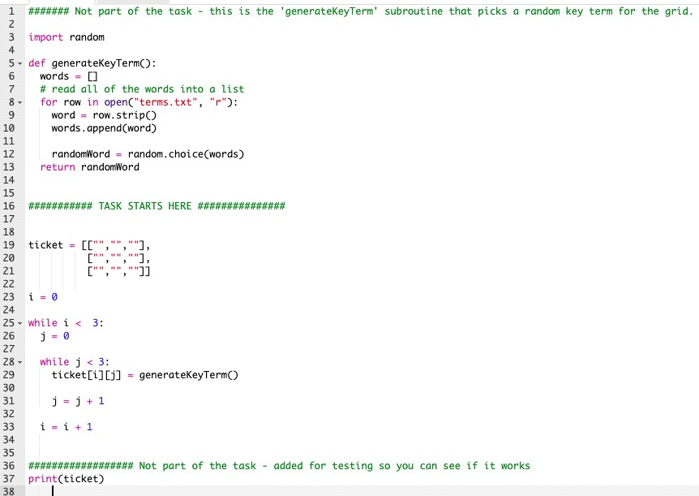
https://trinket.io/python3/f1c9029c23
From <https://trinket.io/library/trinkets/f1c9029c23>
OCR Tech
OCR Tech is an online shop that sells electronics such as TVs and game consoles.
SCREENSHOT YOUR COMMENTED CODE HERE

Customers can use a discount code to reduce the price of their purchase. Valid discount codes and their value (in pounds) are stored in a global two-dimensional (2D) array with the identifierdiscount. The following table shows part of this 2D array.

For example,discount[2,0]holds discount code BGF2 anddiscount[2,1]holds the discount of 15 pounds.
A function searches through the 2D array and applies the discount to the price. The price and discount code are passed in as parameters. The algorithm design is not complete.
Complete the design for the algorithm, you will need to rewrite the pseudocode as Python code.
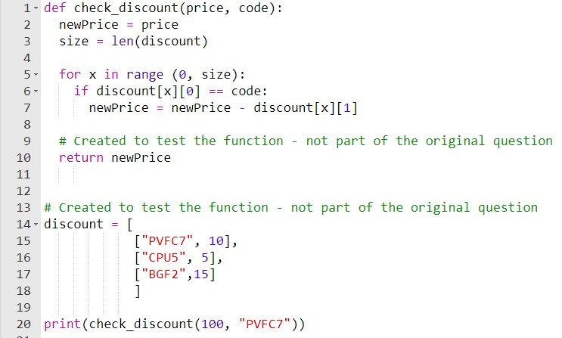
https://trinket.io/python3/33c637656
6
From <
https://trinket.io/library/trinkets/33c637656
6
>

OCR FC - Goals Array
Elliott plays football for OCR FC. He wants to create a program to store the results of each football match they play and the names of the goal scorers. Elliott wants individual players from the team to be able to submit this information.
SCREENSHOT YOUR COMMENTED CODE HERE

The number of goals scored in each football match is held in an array calledgoals. An example of this array is shown.
goals = [0, 1, 3, 0, 4, 5, 2, 0, 2, 1]
Elliott wants to count how many matches end with 0 goals.
Convert the following pseudocode for an algorithm into Python.
The program should count up how many matches with 0 goals are stored in the array and then print out this value.
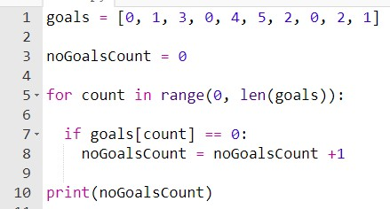
https://trinket.io/python3/6794874ae
1
From <
https://trinket.io/library/trinkets/6794874ae
1
>

Solution - 600 - Logging In
26 March 2020 08:07
Write a program which asks a user for a unique ID. It should then check the ID against a list of ID's stored.
If the ID matches one in the list, the user will be authorised and a relevant message will display.
If not, the user will be asked to enter their ID again. They will get 3 goes before they are locked out.
You will need to create a list of ten unique ID's for this challenge.
Each ID will compromise of two letters and four numbers in the following format:
- SD5545
The user will then have to enter their own ID. If the ID they enter matches one in the list, they will be greeted. E.g.
- "Hello user SD5545. You have been authorised."
If it doesn't match, they will get another two goes at entering an ID before a suitable message is displayed and they are locked out.
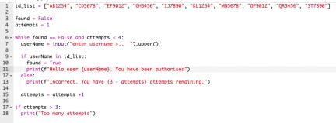
- "ID wrong. You have been locked out."
Each time they try and get it wrong, they should be told how many attempts they have left.
SCREENSHOT YOUR COMMENTED CODE HERE
https://trinket.io/python3/903a9832b
9
Quick Notes Page 174
Solution - 600 - Game Time - Day Of The Week
15 March 2023 10:03
Heath is researching how long, to the nearest minute, each student in his class spends playing computer games in one week (Monday to Friday). He is storing the data in a 2D array.
Fig. 2 shows part of the array, with 4 students.

For example, student 1, on Monday (day 0), played 30 minutes of computer games.
Heath has the day of the week stored as a number e.g. 0 = Monday, 1 = Tuesday.
Write a sub-program that takes the number as a parameter and returns the day of the week as a string.
SCREENSHOT YOUR COMMENTED CODE HERE
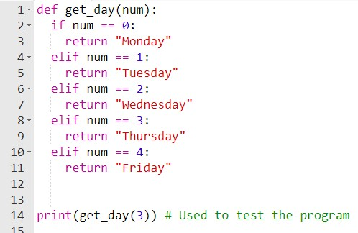
https://trinket.io/python3/d3fdf6c33e
From <https://trinket.io/library/trinkets/d3fdf6c33e>

Quick Notes Page 176
Solution - 600 - Email Validator
26 March 2020 08:17

Solution - Email Validator
SOLUTION
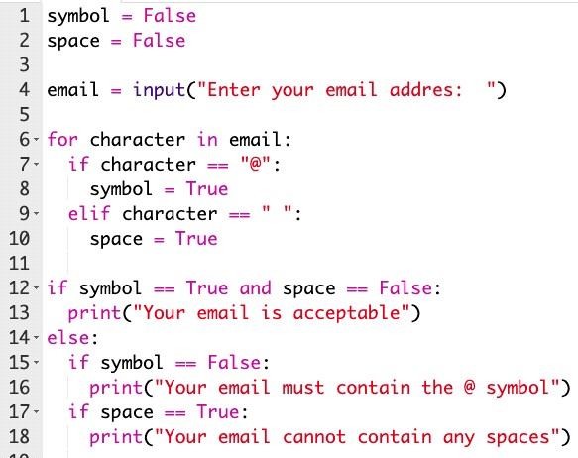
https://trinket.io/python3/d6e219c5f3?showInstructions=true

600 Pin Checker
08:17

Solution - Pin Checker
Write a program that can check how strong a user's PIN number is.
The user will need to input their PIN number and the program will output whether it is strong or not, and if not give the reason why.
SCREENSHOT YOUR COMMENTED CODE HERE
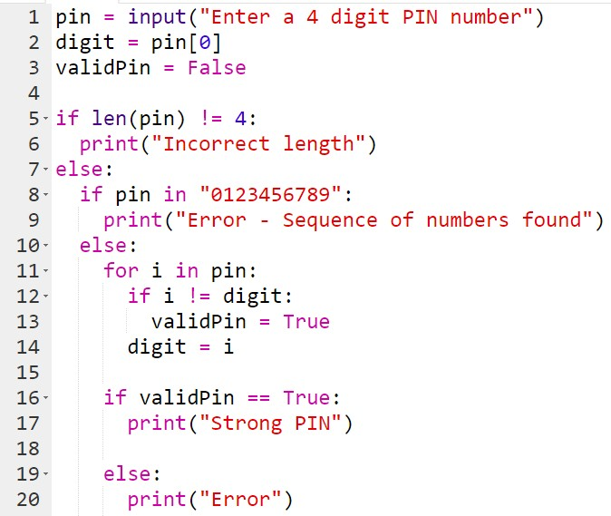
https://trinket.io/python3/5fccc9940a
SCREENSHOT THE OUTPUT HERE
Pin numbers MUST be 4 digits long.
Allow the user to input their pin as an integer. E.g.
- 4335
The program will then check if the pin number is strong by making sure:
* The pin is not four consecutive numbers. E.g, '1234', or '5678' * The pin is not four identical numbers. E.g. '0000' or '8888'
If the pin is not strong, a message will appear telling them why.
Otherwise the user will be told they have a strong pin number.

6th Form Admissions
SCREENSHOT YOUR COMMENTED CODE HERE
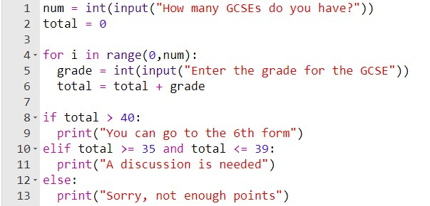
https://trinket.io/python3/f66db1b716
From <https://trinket.io/library/trinkets/f66db1b716>
SCREENSHOT THE OUTPUT HERE
Write a program that:
- Ask the user to input how many GCSE’s they have.
- They should then be allowed to enter a result for each GCSE grade.
- The computer should work out how many points they have got (9=9, 8=8, 7=7 etc).
● | If their score is 40 or over it should output ‘You can go to the sixth form’
● | If they their score between 35 and 39 it should output ‘A discussion is needed’
● | Otherwise it should say ‘Sorry not enough points.’

Free Electricity!
Roger has switched to a new electric supplier.
SCREENSHOT YOUR COMMENTED CODE HERE
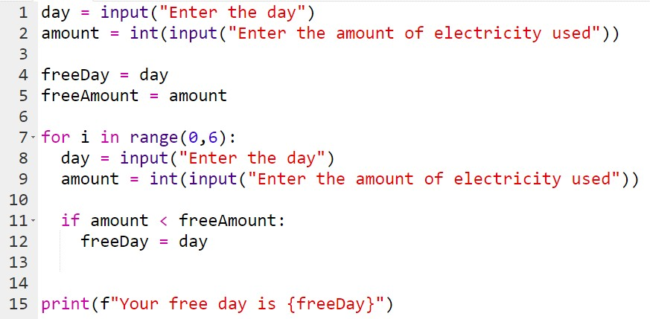
https://trinket.io/python3/024c1f1754
From <https://trinket.io/library/trinkets/024c1f1754>
SCREENSHOT THE OUTPUT HERE
He will receive free electric one day a week. He will not pay for the day that he uses the least amount of electricity.
Write a program that will:
- Allow the user to input each day of the week and then unit of units of electric used.
- Compare them until all comparisons are completed.
- Output the day that will be free of charge.
How Many Cars?
Roger has switched to a new electric supplier.
He will receive free electric one day a week. He will not pay for the day that he uses the least amount of electricity.
SCREENSHOT YOUR COMMENTED CODE HERE
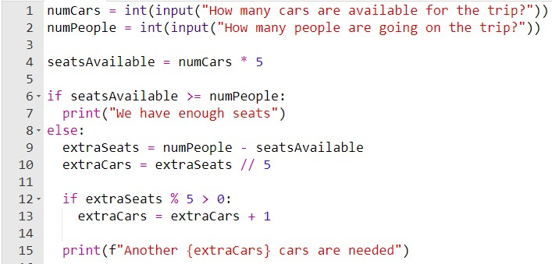
https://trinket.io/python3/0c0ce26bce
From <https://trinket.io/library/trinkets/0c0ce26bce>
SCREENSHOT THE OUTPUT HERE
Write a program that:
- Asks the user to input many cars are available for a trip.
- Asks the user to input how many people are going on the trip.
- If there are enough seats it should output ‘We have enough seats’
- If there are not enough seats it calculate how many extra cars are needed and then output ‘Another x cars are needed’ with x being the number of cars.
NOTE: Assume you can fit FIVE people in each car.

*** 800 Pts
17 March 2023 11:25
2D arrays
Complex subroutines
Quick Notes Page 182
800 - Game Time - Total Time
15 March 2023 10:03
Heath is researching how long, to the nearest minute, each student in his class spends playing computer games in one week (Monday to Friday). He is storing the data in a 2D array.
Fig. 2 shows part of the array, with 4 students.

For example, student 1, on Monday (day 0), played 30 minutes of computer games.
Heath needs to work out the average number of minutes spent playing computer games each day for the class, which contains 30 students. Write an algorithm to output the average number of minutes the whole class spends playing computer games each day.
Click here for the starter code with the array made for you.
SCREENSHOT YOUR COMMENTED CODE HERE
800 - Inverse Image
15 March 2023 10:03
A black and white image can be represented as a two-dimensional array where:
- 0 represents a white pixel
- 1 represents a black pixel.
Two images are exact inverses of each other if:
- every white pixel in the first image is black in the second image
- every black pixel in the first image is white in the second image.
For example, B is the inverse of A but C is not the inverse of A:
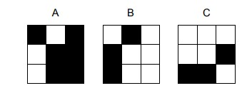
A developer has started to create an algorithm that compares two 3x3 black and white images, image1 and image2, to see if they are exact inverses of each other.
Complete the algorithm given below, ensuring that, when the algorithm ends, the value of the variable inverse is true if the two images are inverses of each other or false if they are not inverses of each other.
The algorithm should work for any 3x3 black and white images stored in image1 and image2.
• Note that indexing starts at zero.
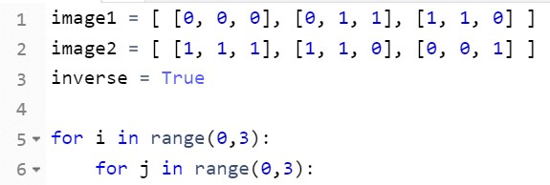
Click here to open the starter code.

SCREENSHOT YOUR COMMENTED CODE HERE

800 - Battleships
15 March 2023 10:03
A developer wants to simulate a simple version of the game of Battleships™.
The ships are located on a one-dimensional array called board.
There are always three ships placed on the board:
- one ‘carrier’ that has size three
- one ‘cruiser’ that has size two
- one ‘destroyer’ that has size one.
The size of the board is always 15 squares.
A possible starting configuration is shown in Figure 9 where the indices are also written above the board.
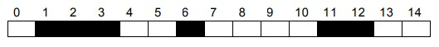
The carrier, for example, is found at locations board[1], board[2]and board[3].
A player makes a guess to see if a ship (or part of a ship) is located at a particular location. If a ship is found at the location then the player has ‘hit’ the ship at this location.
Every value in the board array is 0, 1 or 2.
- The value 0 is used to indicate an empty location.
- The value 1 is used to indicate if a ship is at this location and this location has not been hit.
- The value 2 is used to indicate if a ship is at this location and this location has been hit.
Develop a subroutine that works out how far away the game is from ending.
The subroutine should:
- have a sensible identifier
- take the board as a parameter
- work out and output how many hits have been made
- work out how many locations containing a ship have yet to be hit and:
○ if 0 then output 'Winner'
○ if 1, 2 or 3 then output 'Almost there'.
Click here for the starter code
SCREENSHOT YOUR COMMENTED CODE HERE

Solution - 800 - Game Time - Total Time
15 March 2023 10:03
Heath is researching how long, to the nearest minute, each student in his class spends playing computer games in one week (Monday to Friday). He is storing the data in a 2D array.
Fig. 2 shows part of the array, with 4 students.

For example, student 1, on Monday (day 0), played 30 minutes of computer games.
Heath needs to work out the average number of minutes spent playing computer games each day for the class, which contains 30 students. Write an algorithm to output the average number of minutes the whole class spends playing computer games each day.
SCREENSHOT YOUR COMMENTED CODE HERE

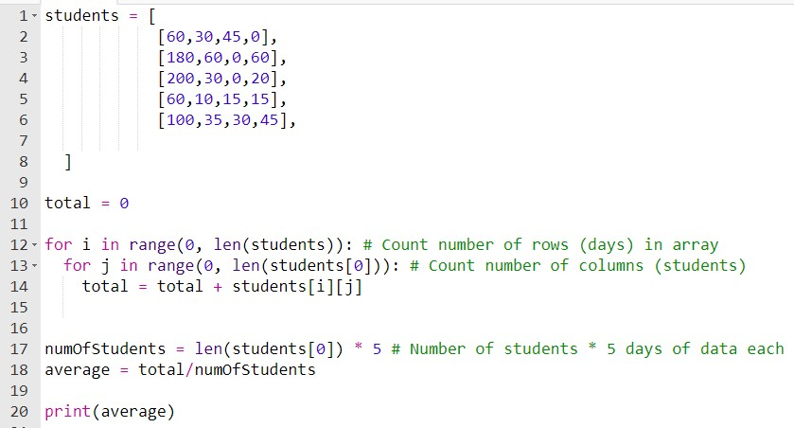
https://trinket.io/python3/2275f5fee
5
From <
https://trinket.io/library/trinkets/2275f5fee
5
>

Solution - 800 - Inverse Image
15 March 2023 10:03
A black and white image can be represented as a two-dimensional array where:
- 0 represents a white pixel
- 1 represents a black pixel.
Two images are exact inverses of each other if:
- every white pixel in the first image is black in the second image
- every black pixel in the first image is white in the second image.
For example, B is the inverse of A but C is not the inverse of A:

A developer has started to create an algorithm that compares two 3x3 black and white images, image1 and image2, to see if they are exact inverses of each other.
Complete the algorithm given below, ensuring that, when the algorithm ends, the value of the variable inverse is true if the two images are inverses of each other or false if they are not inverses of each other.
The algorithm should work for any 3x3 black and white images stored in image1 and image2.
• Note that indexing starts at zero.

SCREENSHOT YOUR COMMENTED CODE HERE

https://trinket.io/python3/107bb0259b
From <https://trinket.io/library/trinkets/107bb0259b>

Solution 800 - Battleships
15 March 2023 10:03
A developer wants to simulate a simple version of the game of Battleships™.
The ships are located on a one-dimensional array called board.
There are always three ships placed on the board:
- one ‘carrier’ that has size three
- one ‘cruiser’ that has size two
- one ‘destroyer’ that has size one.
The size of the board is always 15 squares.
A possible starting configuration is shown in Figure 9 where the indices are also written above the board.

The carrier, for example, is found at locations board[1], board[2]and board[3].
A player makes a guess to see if a ship (or part of a ship) is located at a particular location. If a ship is found at the location then the player has ‘hit’ the ship at this location.
Every value in the board array is 0, 1 or 2.
- The value 0 is used to indicate an empty location.
- The value 1 is used to indicate if a ship is at this location and this location has not been hit.
- The value 2 is used to indicate if a ship is at this location and this location has been hit.
Develop a subroutine that works out how far away the game is from ending.
The subroutine should:
- have a sensible identifier
- take the board as a parameter
- work out and output how many hits have been made
- work out how many locations containing a ship have yet to be hit and:
○ if 0 then output 'Winner'
○ if 1, 2 or 3 then output 'Almost there'.
Click here for the starter code
SCREENSHOT YOUR COMMENTED CODE HERE
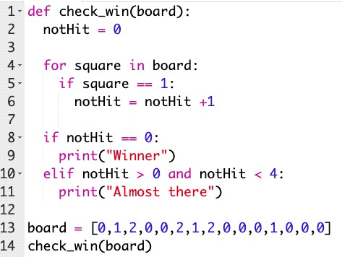
https://trinket.io/python3/a087a57a45?showInstructions=tru
e

Monday, 23 February 2026 02:36

